WEB REGISTRATION INSTRUCTIONS:
Go to the WSU-Rochester homepage (http://www.winona.edu/rochester/).
Click on “Resources”, then “Find A Course”

Once at the “Find A Course” area, click “Log In”

•

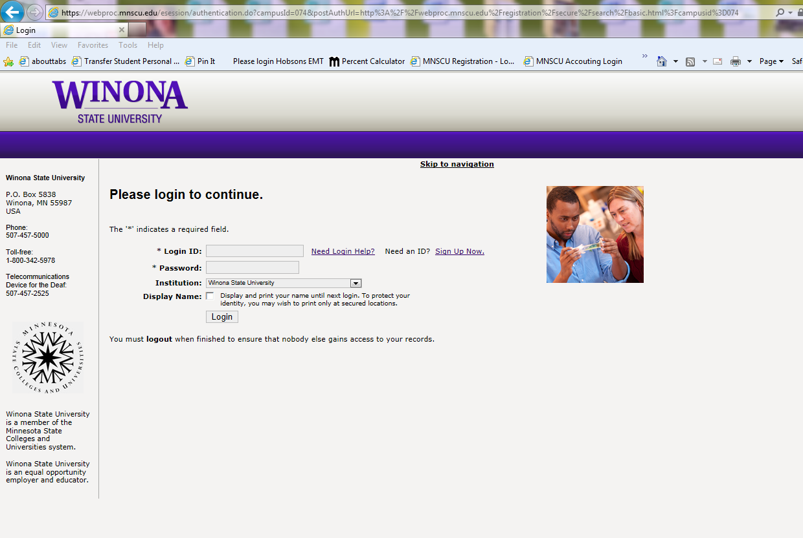

- Enter your Warrior/Tech ID and your PIN
- Check the box if you want your name to display and print on certain pages containing enrollment, obligation, and grade data. This selection will stay in effect until your next login.
- Click on ‘Login’

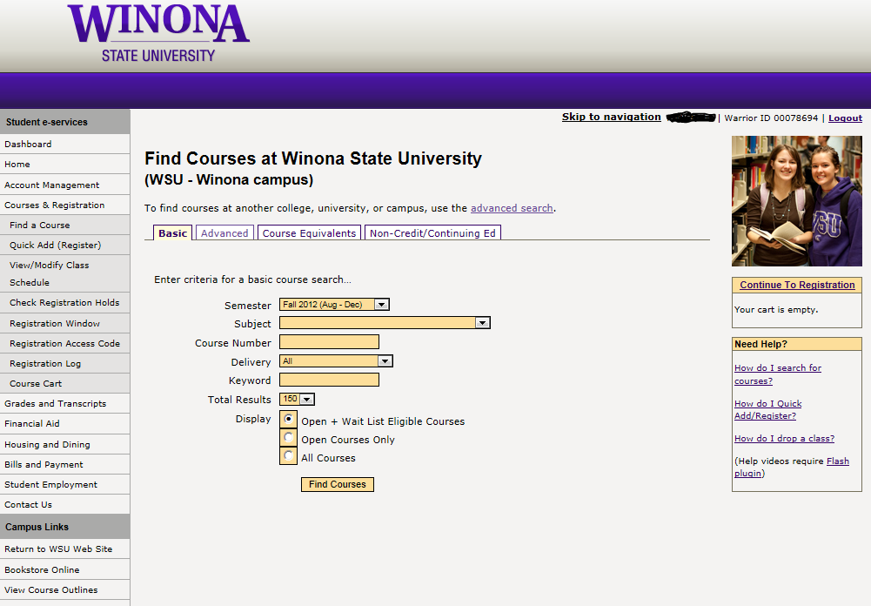

Once at this Student e-services screen, you can manage your account, look up your financial aid, print your DARS or grades, pay your bill or register. For registration, please click on the “Courses & Registration” button:

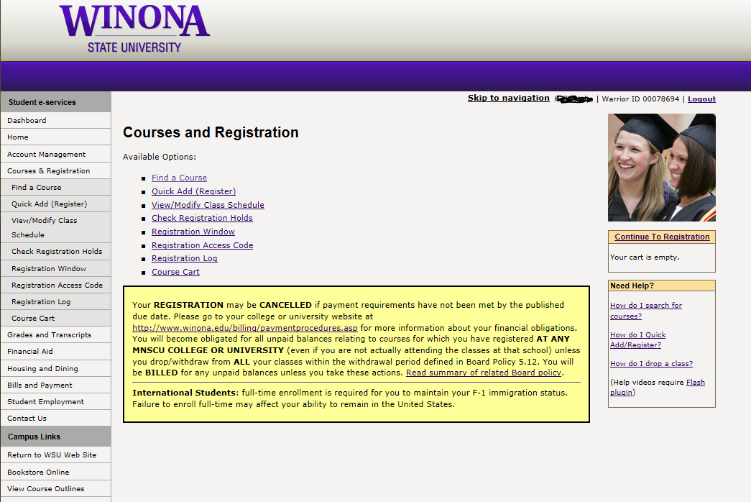

In the “Courses and Registration” area, you can navigate to all the listed areas. If you have the 6 digit course ID, you can use the “Quick Add” area. Otherwise, you can search for courses under the “Find A Course” area. You can also use this screen to check any registration holds you might have, review your registration window, view your course cart and many other functions.

Search for Open Sections:
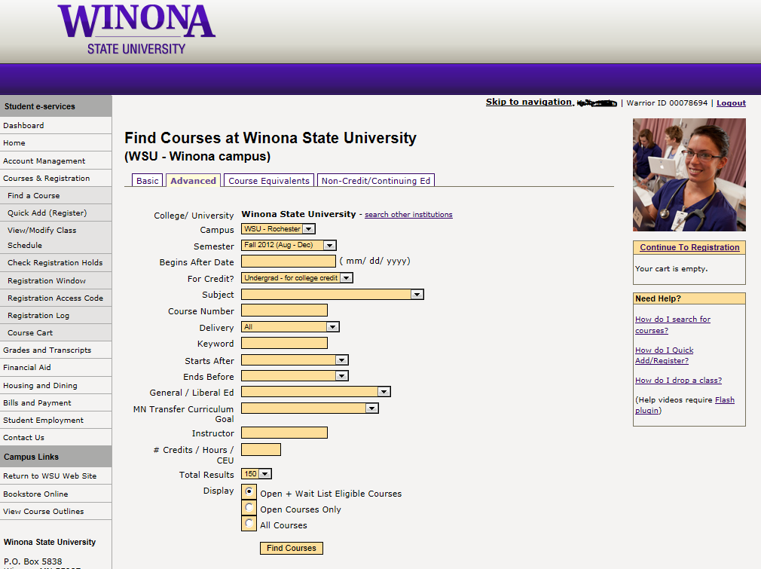
- Click the “Advanced Search” tab. Choose from Winona, Rochester or both campuses by using the drop down arrow. Enter a subject from the drop down list (for example, MATH) or a subject and course number (for example, ENG 111), or a University Studies/General Education code. You may also search for courses based on course start time range by selecting the appropriate values from the drop down menus.
- Choose which courses to display
- Click “Find Course”

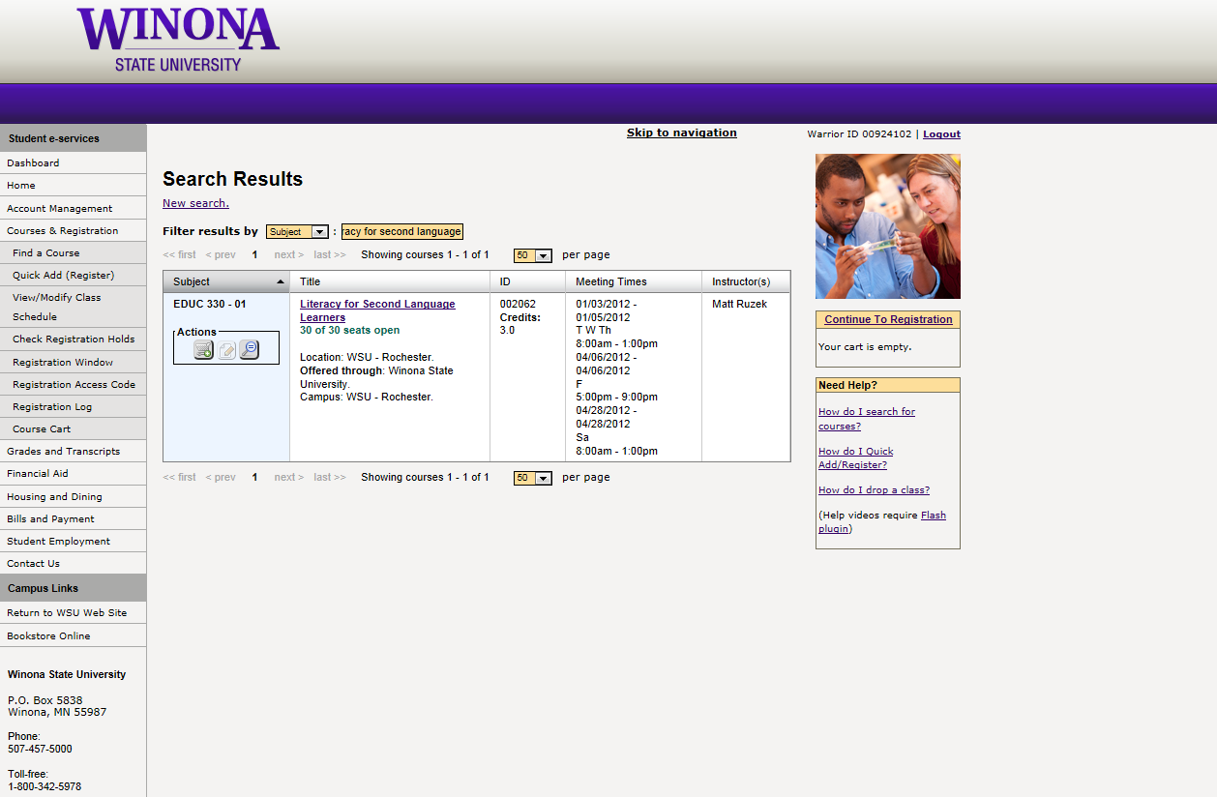
When the courses appear on screen from the result of your inquiry, click the 'Add to cart' icon to the right of the course(s) for which you wish to register. If the course is full and there is a waiting list- you can click ‘add to wait list’.
IMPORTANT NOTE: Registration in selected courses occurs only when you complete the registration process and verify with your PIN and enter your ACCESS CODE.

OTHER WEB OPTIONS
- Under the Courses & Registration sidebar link:
- Click on ‘Quick Add (Register)’ on the menu
- You may enter up to eight course ID numbers at a time
- Click on ‘Register Now’
- Enter your PIN when the next screen appears and click on ‘Process Request’
- Print a paper copy of your class schedule, inspect it, and keep it until after the end of the term
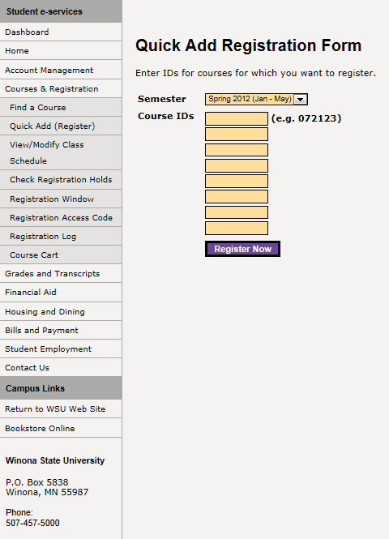

Courses with ‘optional grading’ (letter grade (A through F) or pass/no credit) have ‘letter grade’ as the primary grade type. This is the grade type that you will automatically be given. If you do not wish to have letter grading, click on ‘View/Modify Class Schedule’ on the menu to change your grading method after you have registered for the course.

If you are enrolling in a course that is offered for a variable amount of credits (for example, 1-4 credits), you MUST enter the number of credits that you wish to register for in the ‘Variable Credit’ column – this is a 4-digit field with an implied decimal point (2 credits would be entered as 0200).

Change the Grading Method of a Class:
Note: You may not change the grading method for a class after the Drop/Add deadline. You may register for no more than 6 credits P/NC in a semester.
- Click on ‘View/Modify Class Schedule’ on the menu (your schedule will appear)
- Click on the course ID of the course for which you want to change the grading method
- Select ‘Change Grade Method’ from the drop down list
- Select the appropriate grade method from the Grade Method drop down list Tab down and click on ‘Process’
- Enter your PIN number for verification and click on ‘Process Request’
- Print a paper copy of your class schedule, inspect it, and keep it until after the end of the term
Drop a Class:
Note: If you drop a class before the Drop/Add deadline, it does not appear on your academic record. If you withdraw from a class after the Drop/Add deadline, a "W" is recorded on your transcript and you are not eligible for a full refund of tuition for the class. You may not withdraw from a class after the final drop date.
- Click on ‘View/Modify Class Schedule’ on the menu (your schedule will appear)
- Click on the course ID for the course you want to drop
- Make sure that ‘Drop’ appears in the selection box
- Tab down and click on ‘Process’
- Enter your PIN number for verification and click on ‘Process Request’
- Print a paper copy of your class schedule, inspect it, and keep it until after the end of the term

IMPORTANT NOTE: Registration in classes commits you to a financial obligation. If you decide not to attend, classes must be dropped prior to the posted deadline to receive a full refund of tuition and fees.
Change Year/Term
The web registration system will automatically default to a specific year/term. If you want to access a different term, click on Courses & Registration link on the left sidebar. There will be a link on the page that reads Change Semester. Follow the drop down menu to change the year term.
Entering your Registration Access Code:
All Winona State University students are required to meet with their advisor and obtain a Registration Access Code. You will be prompted to enter your Registration Access Code during registration. Once you have entered the code, you will not be prompted for it again.
NOTE: Access Codes are not required for Summer Term registration.

Logout of Web Registration:
- Click on ‘Logout’ at the upper right corner of the screen
- Close the web browser - failure to close the browser may allow others to view your data
Note: To prevent unauthorized viewing of your private data, always logout from the system to end your session and close all browser windows on your machine.
Web Registration Directions
Tip: Use the schedule search service on the Class Schedules page to see special notes that do not appear on the Web Registration site. You may want to open another web browser that you can keep both pages open at the same time.

