# Minnesota

# BSW IV-E Child Welfare Consortium

# Stipend Program

**Winona State University**



**Project Staff**

*For application deadlines, applications, and/or*

*other program information:*

**Ruth Charles, MSW, PhD**

[rcharles@winona.edu](mailto:debra.gohagan@mnsu.edu)

507-457-5674

**Jessica Tye, MSW**

jtye@winona.edu

507-280-5568

**Department of Social Work**

**Winona State University**

**http://www.winona.edu/socialwork/childwelfarestipend.asp**

|  |
| --- |
|  |

### Minnesota BSW Child Welfare Consortium Member Schools

Minnesota State University, Mankato

Department of Social Work

Mankato, MN

Winona State University

Department of Social Work

Winona, MN

St. Cloud State University

Department of Social Work

St. Cloud, MN

Bemidji State University

Department of Social Work

Bemidji, MN

Minnesota State University Moorhead

Department of Social Work

Moorhead, MN

University of Minnesota,

School of Social Work and

Center for Advanced Studies in Child

Welfare

St Paul, MN

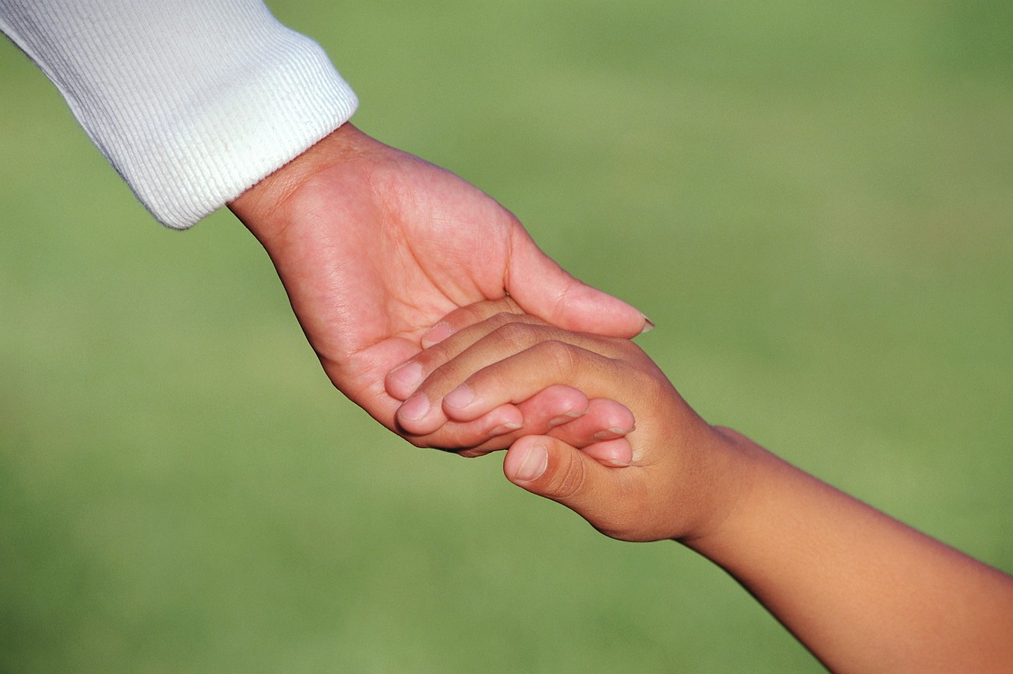

**TO BE ELIGIBLE, STUDENTS MUST BE:**

* Enrolled at Winona State University and have been accepted to the WSU Social Work program and be in good academic standing.
* Willing to expand their educational preparation to develop their potential as child welfare professionals.
* Interested in a careers in public child welfare.
* Willing to seek employment in a public child welfare agency, primarily in out-state Minnesota, for 4.5 months for each semester of stipend support.
* US citizens.

## BENEFITS FOR UNDERGRADUATE SOCIAL WORK STUDENTS

* Guidance for students’ efforts to focus their academic and pre-professional preparation for public child welfare careers.
* Students participate in curriculum and training opportunities that prepare them to meet the challenges of child welfare careers.
* Students complete practicum placements in public child welfare agencies.
* After graduation, students are employed primarily in out-state public child welfare agencies in Minnesota.
* Students receive $1900 stipend for each semester they participate in this program.
* j0115856

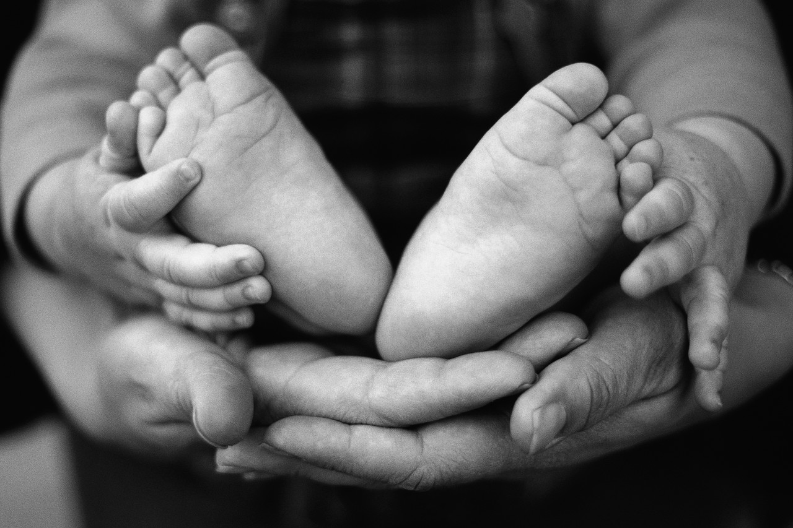

### Benefits for

### county and State social service offices

* This program recruits and educates undergraduate child welfare students for public child welfare careers.
* Students complete additional curriculum content and learning opportunities to better prepare for child welfare employment.
* Graduates complete their senior practicum in a public child welfare agency.
* Counties have a pool of ‘seasoned undergraduate students’ to hire from and can request the names of graduates from member schools.
* Graduates are committed to seeking and accepting employment in public child welfare agencies to ‘repay’ the stipend.
* No matching funds are required from the counties to participate in this program.
* Merit system rules apply.

### Consortium Stipend Program overview

Children and families are the heart of a healthy society and are often one of the most underserved populations. Working with children and families can be very demanding; thus, the child welfare profession experiences a high degree of turnover in staff, nationally and locally. It can also be very rewarding!

The purpose of this stipend program is to prepare undergraduate professional social workers to meet these challenges. A primary goal of this stipend program is to strengthen the preparation and education of BSW social workers who plan to work in Title IV-E eligible public child welfare agencies in Minnesota, preferably in non-metro areas.

County social services directors report that the collaboration between Minnesota State universities’ member programs and the University of Minnesota positively impacts recruitment and retention of social work-educated child welfare employees in rural areas.

For information on open positions or to submit your resume, please visit our Web site at: www.lucernepublishing.com