Search Advisory Committee Training Log-In Instructions

- Log into the State of Minnesota Employee Self-Service website using Chrome. You can find the link in the bottom right hand corner of the WSU Human Resource page. Or use this shorten ULR: http://bit.ly/1EKXpvu

- Once logged in under Main Menu select State of MN Self Service and then Enterprise Learning Mgmt (ELM)

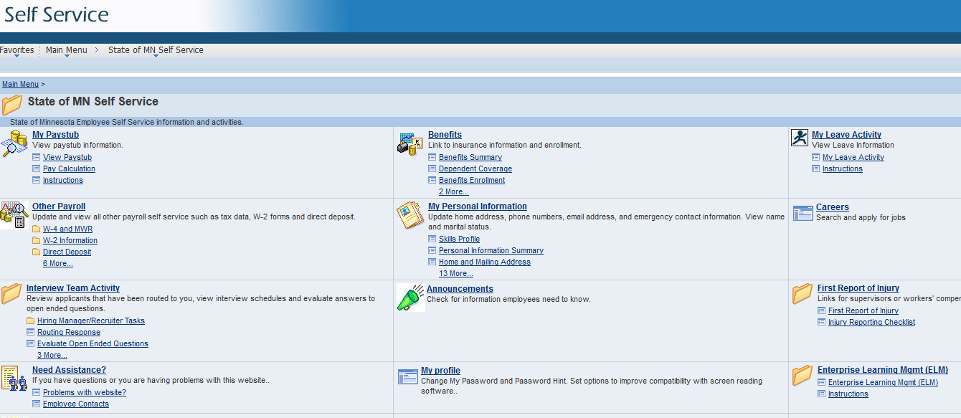

- Next under the Search for Learning type in: Search Advisory Committee Training and press enter.

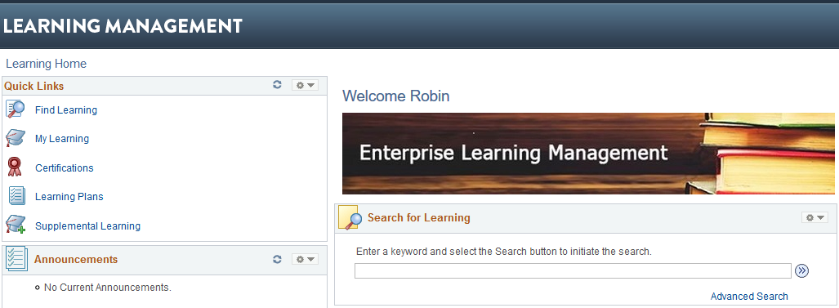

- Select Register

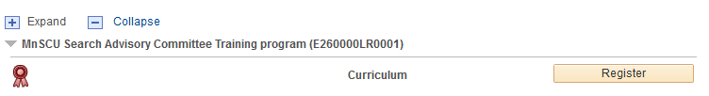

Note: Repeat the steps below to review all four required training modules

- Click Enroll on the right hand side of the module you wish to review:

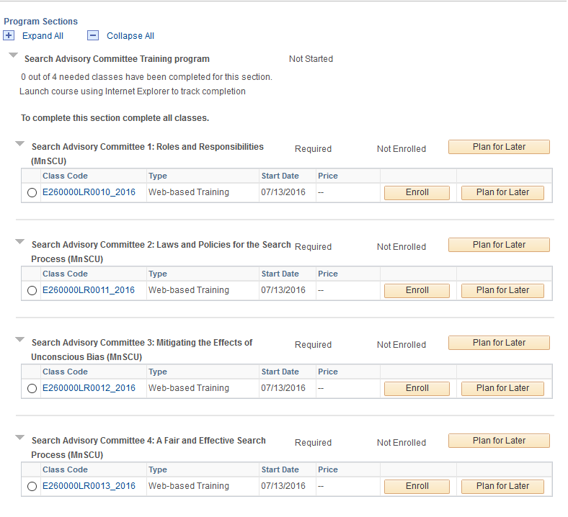

- Under Class Progress, click on Launch

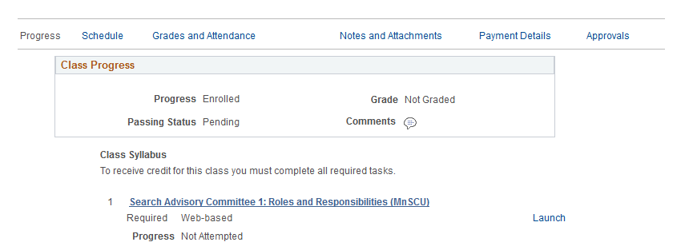

- Under Table of Contents, click on Launch
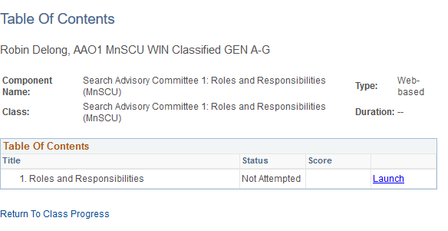

- Repeat Steps 5-7 the above steps to complete all four required training models:
  - Roles and Responsibilities of Search Advisory Committee Members
  - Laws and Policies for the Search Process
  - Mitigating the Effects of Unconscious Bias
  - A Fair and Effective Search Process

- After completing all four modules, print, sign and return the Confidentiality Agreement (available at http://www.winona.edu/affirmativeaction/Media/Confidentiality-Agreement.pdf) to the AA/Equity & Legal Affairs Office (Somsen 202).

